

USER MANUAL
OPERATING & INSTALLATION INSTRUCTIONS

CONTENTS
1. INTRODUCTION
1.1. SPECIFICATIONS AND DIMENSIONS
1.2. HEALTH AND SAFETY PRECAUTIONS
2. INSTALLATION INSTRUCTIONS
2.1. UNPACKING THE STOVE
2.2. FLOOR, SAFETY DISTANCE AND VENTILATION IN THE ROOM
2.3. CONNECTIONS TO FLUES AND CHIMNEY

3. OPERATING INSTRUCTIONS
3.1. FUELING & REFUELLING
3.2. LIGHTING
3.3. NORMAL OPERATION AND CONTROLLING THE FIRE
3.4. ASH CLEARANCE AND DEFLECTORS

4. MAINTENANCE AND IMPORTANT ADVICES
4.1. FIREBOX, COOKING OVEN AND FLUEWAY CLEANING
4.2. CHIMNEY SWEEPING
4.3. IMPORTANT ADVICES
4.4. TROUBLE SHOOTING
4.5. IF YOU NEED FURTHER HELP

1. INTRODUCTION

Our valued Customer,
Çalışkan is grateful to you for choosing this stove and ensures that the stove you purchased operates in compliance with the operating rules.
Before installing and operating this stove, read this user manual carefully and pay attention to the warnings!
Before lighting the stove check with the installer that the work and checks described in the Installation Instructions have been carried out correctly and that the chimney has been swept, is sound and free from any obstructions.

You purchased the model:

305 fireplace stove 305-3D fireplace stove
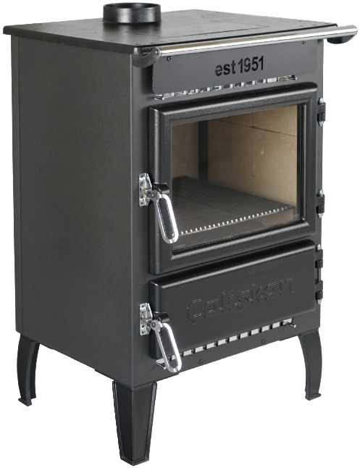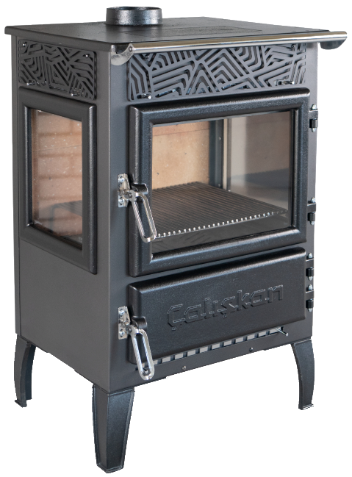

305-BOX fireplace stove 305-3D-BOX fireplace stove
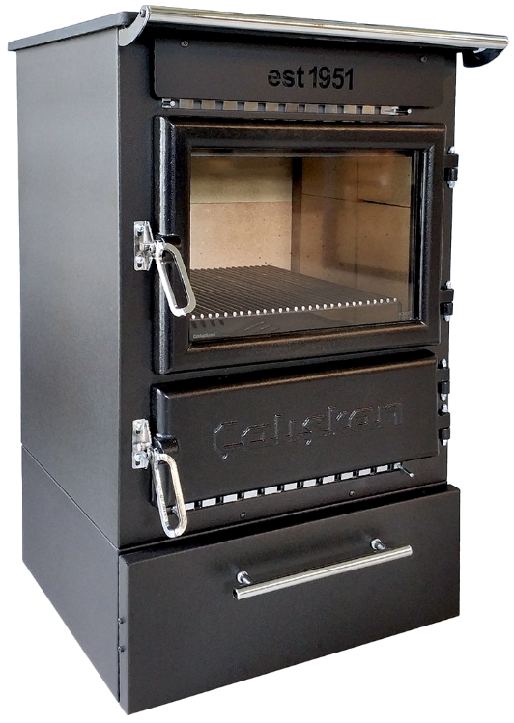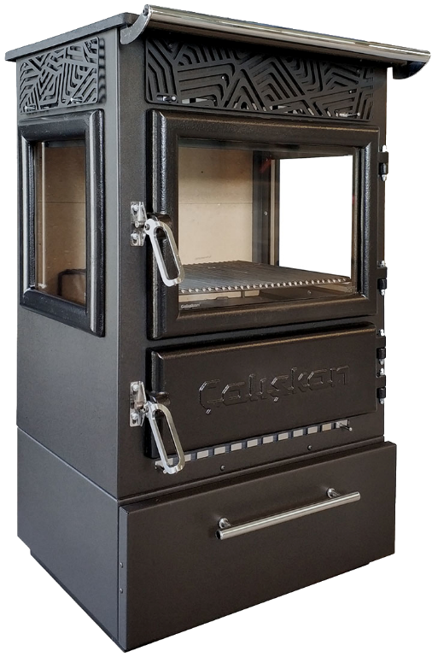

304 mini fireplace stove 304-3D mini fireplace stove 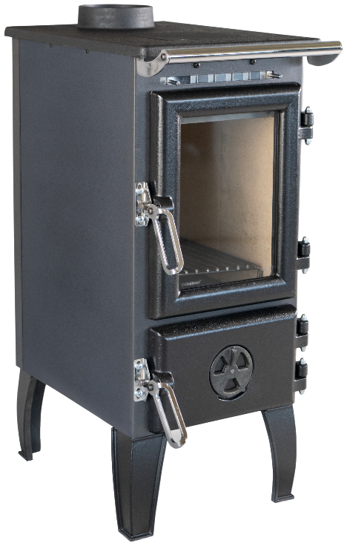 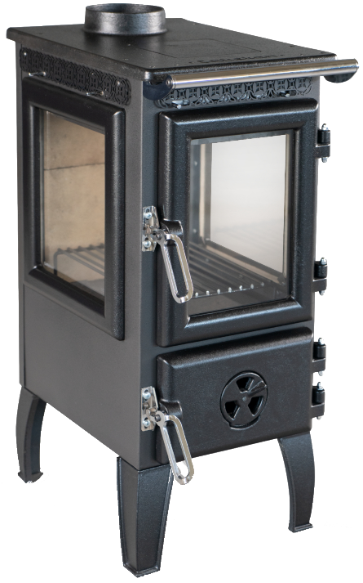
301 fireplace stove
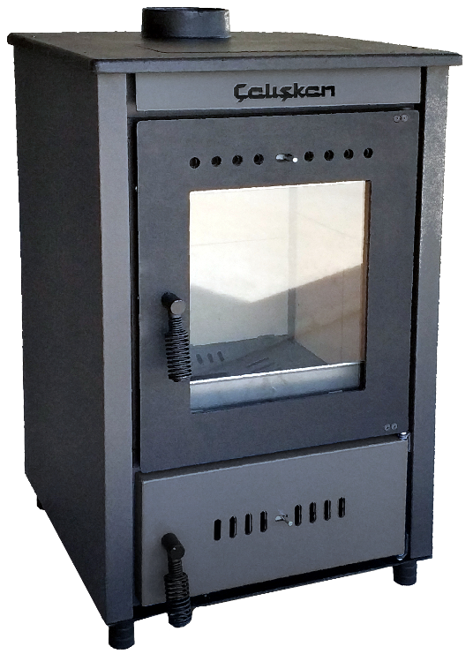

315 fireplace stove 315-3D fireplace stove
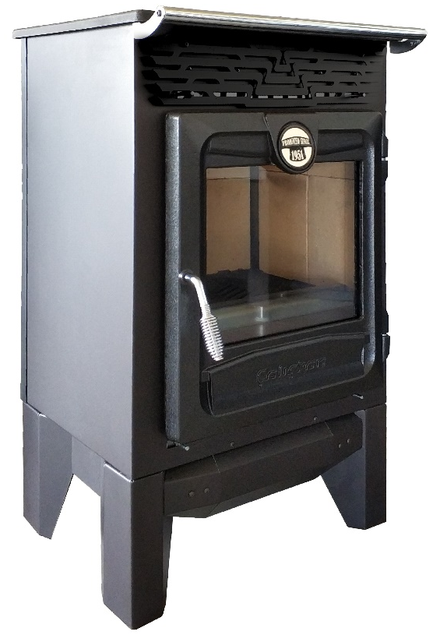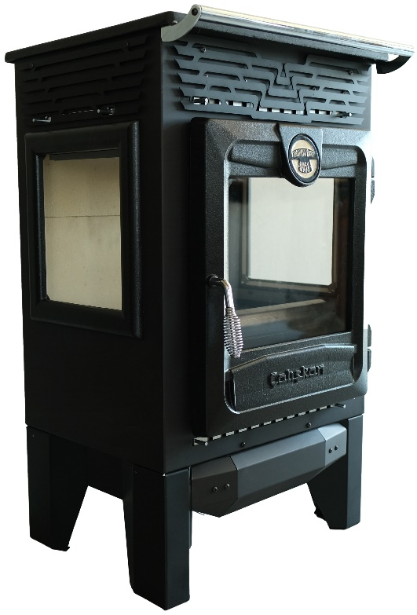

315-BOX fireplace stove 315-3D-BOX fireplace stove
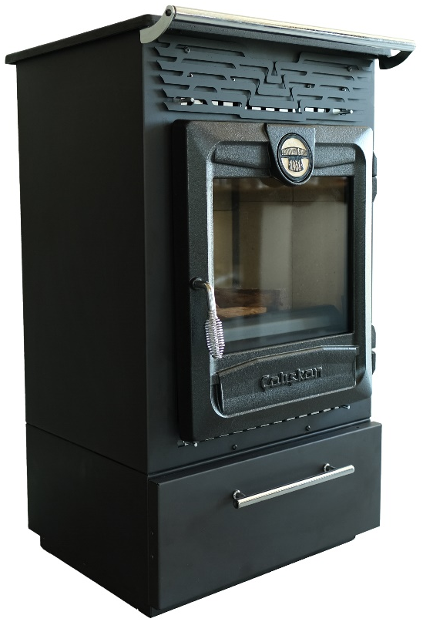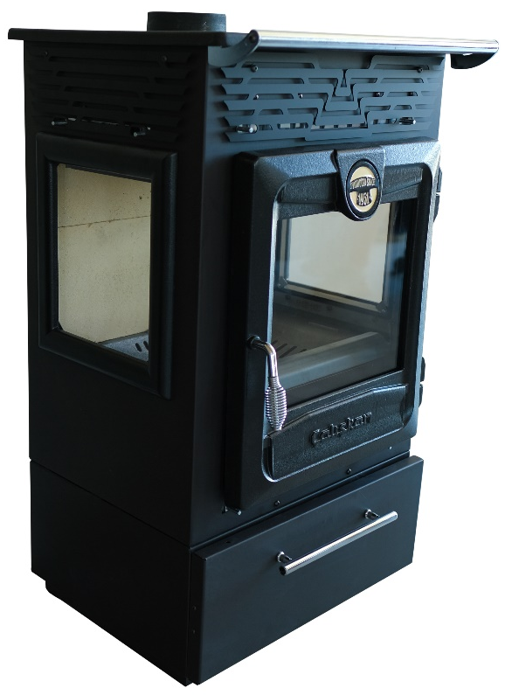

This stove and our other stoves are constantly being developed. Çalışkan reserves the right to make changes to its products and the data contained in the user manual without prior notice.

ATTENTION!
STOVE SURFACES CAN BE VERY HOT! ALWAYS USE SUFFICIENT PROTECTIVE GLOVES!
During combustion, thermal energy is released, which significantly increases the temperature of the entire stove, surfaces, doors, handles, controls, glass, exhaust pipes. Before installing and operating this stove, read this user manual carefully and heed the warnings!

This user manual is an integral part of the product. Make sure that the user manual is always with the stove, even if it is transferred to another owner or user or transferred to another location. If the user manual is damaged or lost, request new copy from the place where you purchased the stove.

1.1. SPECIFICATIONS AND DIMENSIONS
TECHNICAL DESCRIPTION
The chimney stoves of Çalışkan are suitable to heat living spaces for some periods. As fuel, dry wood logs are used. The stove works as an intermittent operating appliance.
The stove is made of sheets of metal in galvanized steel, enamelled cast iron and, depending on the model, thermo radiant ceramics or soapstones or other stones.
The hearth is internally sheathed with single cast iron.
The hearth is equipped with a panoramic cast iron door with ceramic glass (resistant up to 700 °C). This allows a wonderful view on the burning flames. Furthermore, it is thus avoided the output of sparks and smoke.
Below the hearth door will be found an extractable ash-drawer with a closing door (Picture 9).

 | 305 | 305 - 3D | 305 - BOX | 305 - 3D - BOX | 304 | 304 - 3D | 301
Defnition in according to: | EN 13240 -2006
Direct heat output | 12,50 kW |  |  |  | 7,23 kW |  | 12,04 kW
Efficiency in % | 75,20% |  |  |  | 75,80% |  | 75,12%
Smoke outlet diameter in mm | 130 / 150
Maximum amount of Fuel kg/h (wood with 20% humidity)  Hourly consumption in kg/h (wood  with 20% humidity) | 4,4 |  |  |  | 2,2 |  | 3,6
Minimum delivery pressure : | 12,90 Pa |  |  |  | 12,10 Pa |  | 14,55 Pa
CO measured at 13% oxygen  mg/m3 | 1430,56 m g/m3 |  |  |  | 1400,90 m g/m3 |  | 1336,97 m g/m3
Nox measured at 13% oxygen  mg/m3 | 188,33 m g/m3 |  |  |  | 186,32 m g/m3 |  | 165,27 m g/m3
Dust emission at 13% oxygen  mg/m3 | 32,17 m g/m3 |  |  |  | 32,28 m g/m3 |  | 24,61 m g/m3
Exhaust gas temperature °C | 251,03 C |  |  |  | 264,28 C |  | 211,20 C
Height (lukens / plasma leg) mm | 875 |  | 990 |  | 795 |  | 840
Width (lukens / plasma leg) mm | 570 |  |  |  | 520 |  | 490
Depth (lukens / plasma leg) mm | 520 |  |  |  | 335 |  | 485
Net Weight | 100 kg | 97 kg | 112 kg | 109 kg | 56 kg | 60 kg | 90 kg
Type of grill | Flat
Energy efficiency class | A

 | 315 | 315 - 3D | 315 - BOX | 315 - 3D - BOX
Defnition in according to: | EN 13240 -2006
Direct heat output | 14,14 kW
Efficiency in % | 82,16%
Smoke outlet diameter in mm | 130 / 150
Maximum amount of Fuel kg/h (wood with 20% humidity)  Hourly consumption in kg/h (wood  with 20% humidity) | 4,4
Minimum delivery pressure : | 15,00 Pa
CO measured at 13% oxygen  mg/m3 | 1164,14 m g/m3
Nox measured at 13% oxygen  mg/m3 | 152,69 m g/m3
Dust emission at 13% oxygen  mg/m3 | 26,06 m g/m3
Exhaust gas temperature °C | 164 C
Height (lukens / plasma leg) mm | 965 |  | 990
Width (lukens / plasma leg) mm | 570
Depth (lukens / plasma leg) mm | 555
Net Weight | 105 kg | 102 kg | 117 kg | 114 kg
Type of grill | Flat
Energy efficiency class | A+

1.2. HEALTH AND SAFETY PRECAUTIONS
WARNING!
This stove is a wood stove used for heating purposes only!
This stove has been specifically designed for its clearly stated intended use. The manufacturer is exempt from any liability, contractual and extracontractual, for injury/damage caused to persons/animals and objects, due to installation, adjustment and maintenance errors and improper use.

WARNING!
Do not touch the hot stove and its elements without protective gloves! Avoid contact of the hot stove with your body. Make sure children are aware of the danger and keep them away from the stove during operation. Keep flammable materials and cylinders away from the stove. Keep flammable gases away from the room where the stove operates!

SAFETY!
This stove should not be installed and operated by children, people with inadequate physical-sensory-mental capacities, or people with insufficient experience and education-training.
Do not block or restrict the stove's ventilation holes. Original vents are required for proper combustion.
Do not leave packaging elements within reach of children or unsupported disabled people.
The combustion chamber covers should be kept closed while the stove is operating.
In case of chimney fires, use officially applicable systems to smother the flames and seek help from the fire department.
Do not use nylon, waste or similar materials other than dry wood logs as fuel in this stove.
Do not use flammable liquids to ignite logs.

2. INSTALLATION INSTRUCTIONS
WARNING!
Installation must be performed by qualified staff, which assumes complete responsibility for the definitive installation and consequent good functioning of the stove installed. One must also bear in mind all laws and national, regional, provincial and town council standards present in the country in which the stove has been installed, as well as the instructions contained in this user manual.
The Manufacturer cannot be held responsible for the failure to comply with such precautions.

Çalışkan's responsibility is limited to the supply of the stove.
The installation must be carried out scrupulously according to the instructions provided in this user manual and the rules of the profession.
Installation must only be carried out by a qualified technician who works on behalf of companies suitable to assume the entire responsibility of the system as a whole.

Installation of the stove and auxiliary equipment in relation to the heating system must comply with all current Standards and Regulations and to those envisioned by the law.
The installation and the relating to the connections of the system, the commissioning and the check of the correct functioning must be carried out in compliance with the regulations in force by authorized professional personnel with the requisites required by the law, being national, regional, provincial or town council present in the country within which the appliance is installed, besides these present instructions.

2.1. UNPACKING THE STOVE
WARNING!
After removing the packaging, ensure that the content is intact and complete. Otherwise, contact the seller where the appliance was purchased. All components that make up the product must be replaced with original spare parts exclusively by an authorized aftersales center, thus guaranteeing correct functioning.

DISPOSAL OF PACKAGING: The packaging of the Çalışkan stove and all its components complies with the relevant standards and can be disposed of in accordance with the relevant standards. Packaging consists of the following materials: cardboard, wood, polystyrene foam and nylon.

2.2. FLOOR, SAFETY DISTANCE AND VENTILATION IN THE ROOM
▪Installation must be carried out by authorized personnel who must provide the buyer with a system declaration of conformity and will assume full responsibility for final installation and as a consequence the correct functioning of the installed product. The Product, assembled and ready for the installation, must be connected with a junction to the existing flue of the house. The junction must be possibly short, straight, horizontal or positioned a little uphill. The connections must be tight.
Before installing the appliance, carry out the following checks:
▪ UPPER smoke output.
▪ Verify if your structure can support the weight of the stove. In case of insufficient carrying capacity it is necessary to adopt appropriate measures, Çalışkan's responsibility is limited to the supply of the appliance (See chapter TECHNICAL DESCRIPTION).
▪ Make sure that the floor can support the weight of the appliance (for ex. distributing weight plate), and if it is made of flammable material, provide suitable insulation (DIMENSIONS ACCORDING TO REGIONAL REGULATIONS).
▪ Make sure that there is adequate ventilation in the room where the stove is to be installed, with particular attention to windows and doors with tight closing (seal ropes).

When installing the stove, the following safety measures must be observed:
a) In order to ensure sufficient thermal insulation, respect the minimum safety distance from objects or furnishing components flammable and sensitive to heat (furniture, wood sheathings, fabrics. etc.) and from materials with flammable structure (see Picture 5A). All the minimum safety distances are shown on the product data plate and lower values must not be used.
b) In front of the combustion chamber door, in the radiation area there must be no flammable or heat-sensitive objects or material at a distance of less than 100 cm. This distance can be reduced to 40 cm where a rear-ventilated, heat-resistant protection device is installed in front of the whole component to protect.
c) If the stove is installed on a non totally refractory floor, one must foresee a fireproof background. The floors made of inflammable material, such as moquette, parquet or cork etc., must be covered by a layer of no-inflammable material, for instance ceramic, stone, glass or steel etc. (size according to regional law). The base must extend at least 50 cm at the front and at least 30 cm at the sides, in addition to the opening of the loading door (see Picture 5B).

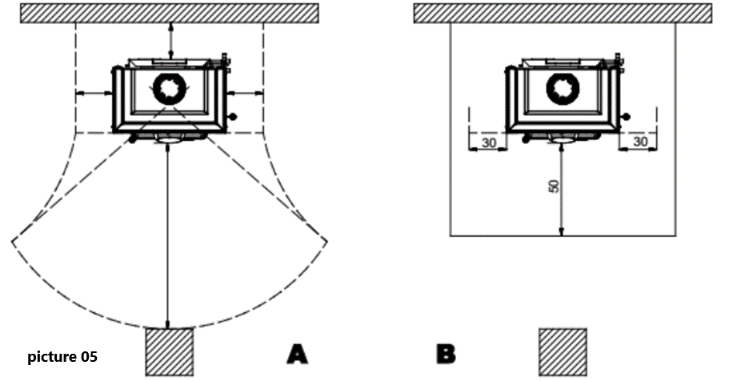
d) No flammable components (e.g. wall units) must be present above the product.
The Product must always operate exclusively with the ash drawer inserted. The solid combustion residues (ash) must be collected in a sealed, fire resistant container. The stove must never be on in the presence of gaseous emissions or vapours (for example glue for linoleum, petrol etc.). Never deposit flammable materials near the stove.
- During combustion, thermal energy is released which leads to considerable heating of the surfaces, doors, handles, controls, glass parts, the flue gas pipe and possibly the front part of the appliance. Avoid contact with these elements unless using suitable protective clothing or accessories (heat resistant gloves, control devices). Ensure children are aware of these dangers and keep them away from the stove when it is operating!
When using the wrong fuel or one which is too damp, due to deposits present in the flue, a flue fire is possible.

VENTILATION AND AERATION OF THE INSTALLATION PREMISES
As the stove draw their combustion air from the place of installation, it is MANDATORY that in the place itself, a sufcient quantity of air is introduced. If windows and doors are airtight (e.g. built according to energy saving criteria), it is possible that the fresh air intake is no longer guaranteed and this jeopardises the draught of the appliance and your health and safety. There MANDATORY be sufcient quantity of air for combustion and re-oxygenation of the room to ensure the device will work properly. There should therefore be vents letting air in from outside the building and enabling circulation of air for combustion even when the doors and windows are closed.
The air inlets must meet the following requirements:
• they must be protected with grids, metal mesh, etc., but without reducing the net useful section;
• they must be made so as to make the maintenance operations possible;
• positioned so that they cannot be obstructed;
• any extractor hoods in the room where the stove is installed must not operate at the same time as this could cause smoke to enter the room, even with the fireplace’s door closed. The clean and non-contaminated air flow can also be obtained from a room adjacent to that of installation (indirect aeration and ventilation), as long as the flow takes place freely through permanent openings communicating with the outside. The adjacent room cannot be used as a garage, or to store combustible material or for any other activity with a fire hazard, bathroom, bedroom or common room of the building.

Installation in premises with fire hazards is forbidden. Installation in residential premises in which, in any case, the depression measured during installation between the internal and external environment is greater than 4 Pa.
All national, regional, provincial and municipal laws and standards in force in the country where the stove is installed must be complied with.
ATTENTION!
Do not install the stove in rooms containing collective ventilation ducts, hoods with or without extractor, type B gas appliances, heat pumps, or other appliances that, operating at the same time, can put the room in depression.

2.3. CONNECTIONS TO FLUES AND CHIMNEY
▪ Make sure that the flue and the pipes to which the stove will be connected are suitable for its operation. It is NOT allowed the connection of various appliances to the same chimney.
▪ The diameter of the opening for connection to the chimney must at least correspond to the diameter of the flue gas pipe. The opening must be equipped with a wall connection for the insertion of the exhaust pipe and a rosette.
▪ The installation must be appropriate and has to allow the cleaning and maintenance of the stove and the flue. Çalışkan declines all responsibility for damage to things and/or persons caused by the system. In addition, it is not responsible for any product modified without authorization and even less for the use of non original spare parts!
Your regular local chimney sweep must be informed about the installation of the stove so that he can check the correct connection to the chimney.

Essential requirements for the flue for the correct stove operation:
• the internal section must preferably be circular;
• the appliance must be thermally insulated and impermeable and built with suitable materials which are resistant to heat, combustion products and any condensation;
• There must be no narrowing and vertical passages with deviations must not be greater than 45°;
• if already used, it must be clean;
• the technical data from the instruction manual must be respected; If the flues are of a square or rectangular section, the internal edges must be rounded with a radius of not less than 20 mm. For the rectangular section, the maximum ratio between the sides must be ≤ 1.5. A section which is too small causes a reduction in draught. A minimum height of 4 m is advisable. The following materials are FORBIDDEN and compromise the good operation of the appliance: asbestos cement, galvanised steel, rough and porousinternal surfaces. Picture 1 shows some example solutions. The minimum section must be 4 dm2 (for example 20x20 cm) for appliances whose pipe dimensions are less than 200 mm, or 6.25 dm2 (for example 25x25 cm) for appliances with a diameter of more than 200 mm The draught created by your flue must be sufcient but not excessive A section of the flue which is too large can present a volume which is too large to heat and therefore cause operating difculties for the appliance; to avoid this, it is necessary to intubate the appliance for its entire height. A section which is too small causes a reduction in draught.

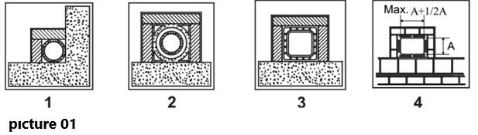

ATTENTION!
As far as concern the realisation of the flue connection and flammable materials please follow the requirements provided. The flue must be at a suitably distance from flammable or combustible material using suitable insulation or an air space. It is FORBIDDEN to pass system piping or air ducts inside the flue. It is also forbidden to create moveable or fxed openings on the flue itself, for the connection of further different appliance.

CHIMNEY POT
The flue draught depends on the suitability of the chimney pot. It is therefore essential that, if built in a handcrafted way, the exit section is more than twice the internal section of the flue (Picture 2) . As it must always go past the ridge of the roof, the chimney pot must ensure exhaust even in the presence of wind (Picture 3). The chimney pot must meet the following requirements:
• Have an internal section equivalent to that of the chimney.
• Have a useful exit section of double the internal section of the flue.
• Be built so as to prevent rain, snow or any foreign body entering the flue.
• Be easy to inspect, for any maintenance and cleaning operations.

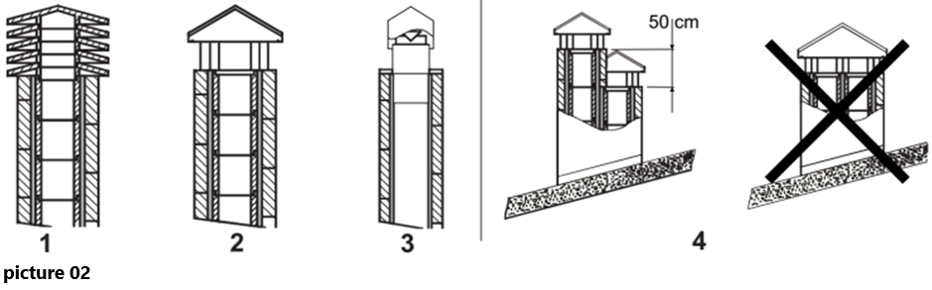

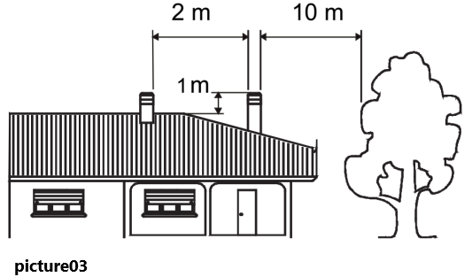

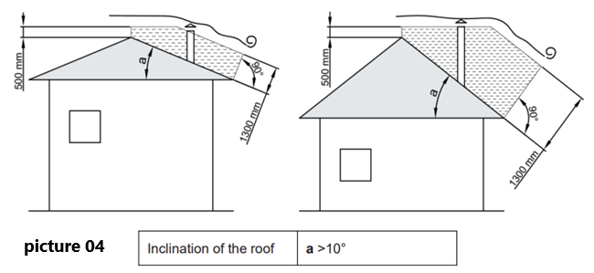

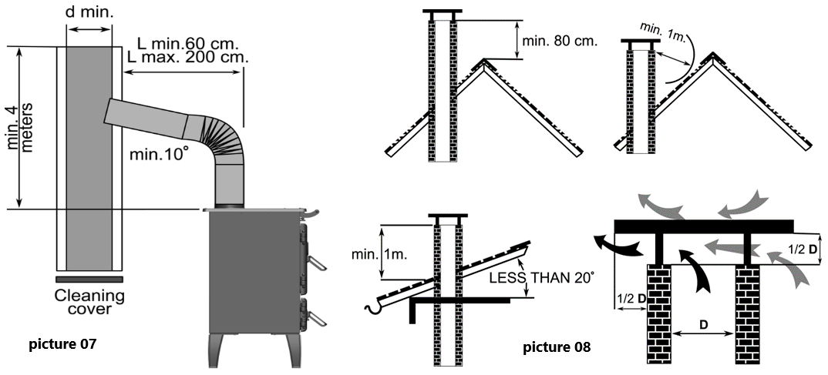

CONNECTION TO THE CHIMNEY
Stoves with automatic door closing must operate, for safety reasons, with the furnace door closed (except during the fuel loading or ash removal phases).
Stoves with non-automatic door closing must be connected to their own flue.
Operation with doors open is only allowed when supervised.
The connection pipe to the flue must be as short as possible, straight horizontal and positioned slightly in ascent, and watertight.
Connection must be carried out with stable and robust pipes, comply with all current Standards and Regulations and to those envisioned by the law, and be hermetically secured to the flue. The internal diameter of the connection pipe must correspond to the external diameter of the appliance flue gas exhaust stub pipe (DIN 1298).
ATTENTION!
As far as concern the realisation of the flue connection and flammable materials please follow the requirements provided. The flue must be properly spaced from any flammable materials or fuels through a proper insulation or an air cavity. Minimum distance safety 25 cm.
The chimney pressure (DRAUGHT) must be at least 12 Pa Pascal (=1.2 mm of water column). The measurement must always be carried out when the appliance is hot (nominal calorific power). When the pressure exceeds 17 Pascal, it is necessary to reduce it through the installation of an additional draught regulator (false air valve) on the exhaust pipe or in the chimney, according to the regulations in force.
For correct appliance operation, it is essential that sufficient air for combustion is introduced into the place of installation (see paragraph VENTILATION AND AERATION OF THE INSTALLATION PREMISES).
3. OPERATING INSTRUCTIONS
STOVE SURFACES CAN BE VERY HOT! ALWAYS USE SUFFICIENT PROTECTIVE GLOVES!

3.1. FUELING & REFUELLING
ALLOWED / NOT ALLOWED FUELS
Allowed fuels are dry wood logs. Use exclusively dry wood logs (max. content of water 20%). Maximum 3 logs should be loaded. The pieces of wood should have a length of ca. 20-30 cm and a maximum circumference of 30-35 cm.
The wood used as fuel must have a humidity content lower than the 20% and must be stored in a dry place. Humid wood tends to burn less easily, since it is necessary a greater quantity of energy to let the existing water evaporate. Moreover, humid content involves the disadvantage that, when temperature decreases, the water condensates earlier in the hearth and therefore in the stack causing a remarkable deposit of soot with following possible risk of fire of the same.
Fresh wood contains about 60% of H2O, therefore it is not suitable to be burnt.
It is necessary to place this wood in a dry and ventilated place (for example under a roof) for at least two years before using it.
Besides others, it is not possible to burn: carbon, cuttings, waste of bark and panels, humid wood or wood treated with paints, plastic materials; in this case, the warranty on the stove becomes void.
The combustion of waste is FORBIDDEN and would even damage the stove and the flue, causing health damages and claims by the neighborhood owing to the bad smell.
The wood is not a fuel which allows a continuous operation of the stove, as consequence the heating all over the night is not possible.
Variety | kg/mc | kWh/kg moistness 20%
Beech | 750 | 4
Oak | 900 | 4,2
Elm | 640 | 4,1
Poplar | 470 | 4,1
Larch * | 660 | 4,4
Spurce * | 450 | 4,5
Scots pine * | 550 | 4,4
* RESINOUS WOOD NOT SUITABLE FOR THE BURNING
PETROLEUM COKE IS NOT SUITABLE FOR USE ON THIS STOVE. ITS USE WILL INVALIDATE THE GUARANTEE!

ATTENTION!
The continuous and protracted use of aromatic wood (eucalyptus, myrtle etc.) quickly damages the cast iron parts (cleavage) of the stove.
The declared technical data have been achieved by burning beech wood class “A1” according to the requirement and wood moisture content less than 20%. By burning a different kind of wood the efciency of the stove itself could change.

3.2. LIGHTING
WARNING!
After the first ignition you can smell bad odours (owing to the drying of the glue used in the garnitures or of the paint) which disappear after a brief using of the appliance. It must be ensured, in any case, a good ventilation of the environment. Upon the frst ignition we suggest loading a reduced quantity of fuel and slightly increasing the calorifc value of the equipment. It is FORBIDDEN to use any liquid substance as for ex. alcohol, gasoline, oil and similar. Never switch on the device when there are combustible gases in the room.

To perform a correct first lighting of the products treated with paints for high temperature, it is necessary to know the following information:
• the construction materials of the involved products are not homogeneous, in fact there are simultaneously parts in cast iron, steel, refractory material and majolica;
• the temperature to which the body of the product is subject is not homogeneous: from area to area, variable temperatures within the range of 300°C - 500°C are detected;
• during its life, the stove is subject to alternated lighting and extinguishing cycles in the same day, as well as to cycles of intense use or of absolute standstill when season changes;
• the new stove, before being considered seasoned has to be subject to many start cycles to allow all materials and paints to complete the various elastic stresses;
• in detail, initially it is possible to remark the emission of smells typical of metals subject to great thermal stress, as well as of wet paint This paint, although during the manufacture it is backed at 250 °C for some hours, must exceed many times and for a given period of time the temperature of 350 °C before becoming completely embedded in the metallic surfaces.

Therefore, it is extremely relevant to take these easy steps during the lighting:
1. Make sure that a strong air change is assured in the room where the stove is installed.
2. During the first starts, do not load excessively the combustion chamber and keep the stove continuously operating for at least 6-10 hours with the registers less open than the value indicated in the instructions manual.
3. During the first starts, no object should be leaned on the stove and in detail on enameled surfaces. Enameled surfaces must not be touched during heating.
4. Once the «break-in» has been completed, it is possible to use the product as the motor of a car, avoiding abrupt heating with excessive loads.

To light the fire, it is suggested to use small wood pieces together with paper or other traded lighting means. The openings for air (primary and secondary) must be opened together. When the wood starts burning, you may load other fuels and adjust the air for combustion according to the instructions on paragraph TECHNICAL DESCRIPTION.
Always be present during this phase.
Never overload the stove. Too much fuel and too much air for combustion can cause overheating and therefore damage the stove. The warranty does not cover the damages due to overheating of the equipment.

LOW EMISSION FIRE LIGHTING
Smokeless combustion is a way of lighting a fire able to significantly reduce the emission of harmful substances. The wood burns gradually from the top downwards, so combustion is slower and more controlled. Burned gases pass through the high temperatures of the flame and therefore burn almost completely.

Place the wooden logs in the combustion chamber at a distance from each other, as shown in Picture 6. Place the largest at the bottom and the smallest at the top. Prepare four logs 15-20 cm long and with a cross section of 3-4 cm x 3-4 cm Picture 6. Cross four logs and, using a fire lighter (e.g. wax-impregnated wood fiber), place them at right angles in the center of the top of the wood pile. You can light the fire with matches.
You can use thinner pieces of wood but in this case you will need a larger amount.
Keep the flue gas exhaust valve and combustion air regulator open!

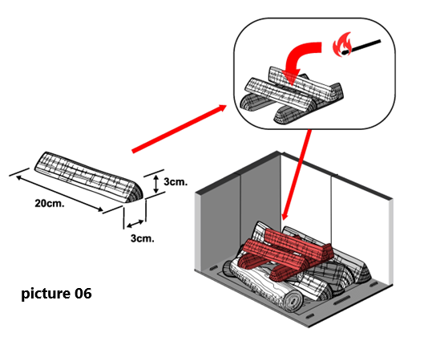

IMPORTANT:
• do not add further wood between one complete load and the next!
• do not suffocate the fire by closing the air intakes!
• regular cleaning by a chimney sweep reduces fne particle emissions!
• When you lighting the stove or adding fuel, use the combustion chamber door only!

3.3. NORMAL OPERATION AND CONTROLLING THE FIRE
After having positioned the registers correctly, insert the indicated hourly wood load avoiding overloads that cause anomalous stresses and deformations (according to the instructions on paragraph TECHNICAL DESCRIPTION). You should always use the product with the door closed in order to avoid damages due to overheating (forge effect). The inobservance of this rule makes the warranty expire.
For safety reasons the door of the appliances with constructive system 1, must be opened only for the loading of the fuel or for removing the ashes, while during the operation and the rest, the door of the hearth must remain closed.
The appliances with constructive system 2 must be connected to their own flue. The operating with open door is allowed under supervision.

The stove is equipped with controls of primary and secondary air by which it is adjusted the combustion air.
A - PRIMARY air register (Picture 9)
With the primary air control (movable valve), which is found below the hearth door it is adjusted the passage of air through the ash drawer and the grate in the fuel direction . The primary air is necessary for the combustion process. The ash drawer must be regularly emptied, so that the ash does not obstruct the primary air entry for the combustion.
Through the primary air the fire is also kept alive. During wood combustion, the register of primary air must be opened only for a while, because otherwise the wood burns fast and the stove may overheat. The register is open when the lever is completely pulled out. The register is closed when the lever is introduced (see chapter NORMAL OPERATION).
B - SECONDARY air register (Picture 9)
Over the hearth door there is the secondary air register. Also this control must be opened, especially for wood combustion, so that unburnt carbon does not undergo a post-combustion (see chapter NORMAL OPERATION).

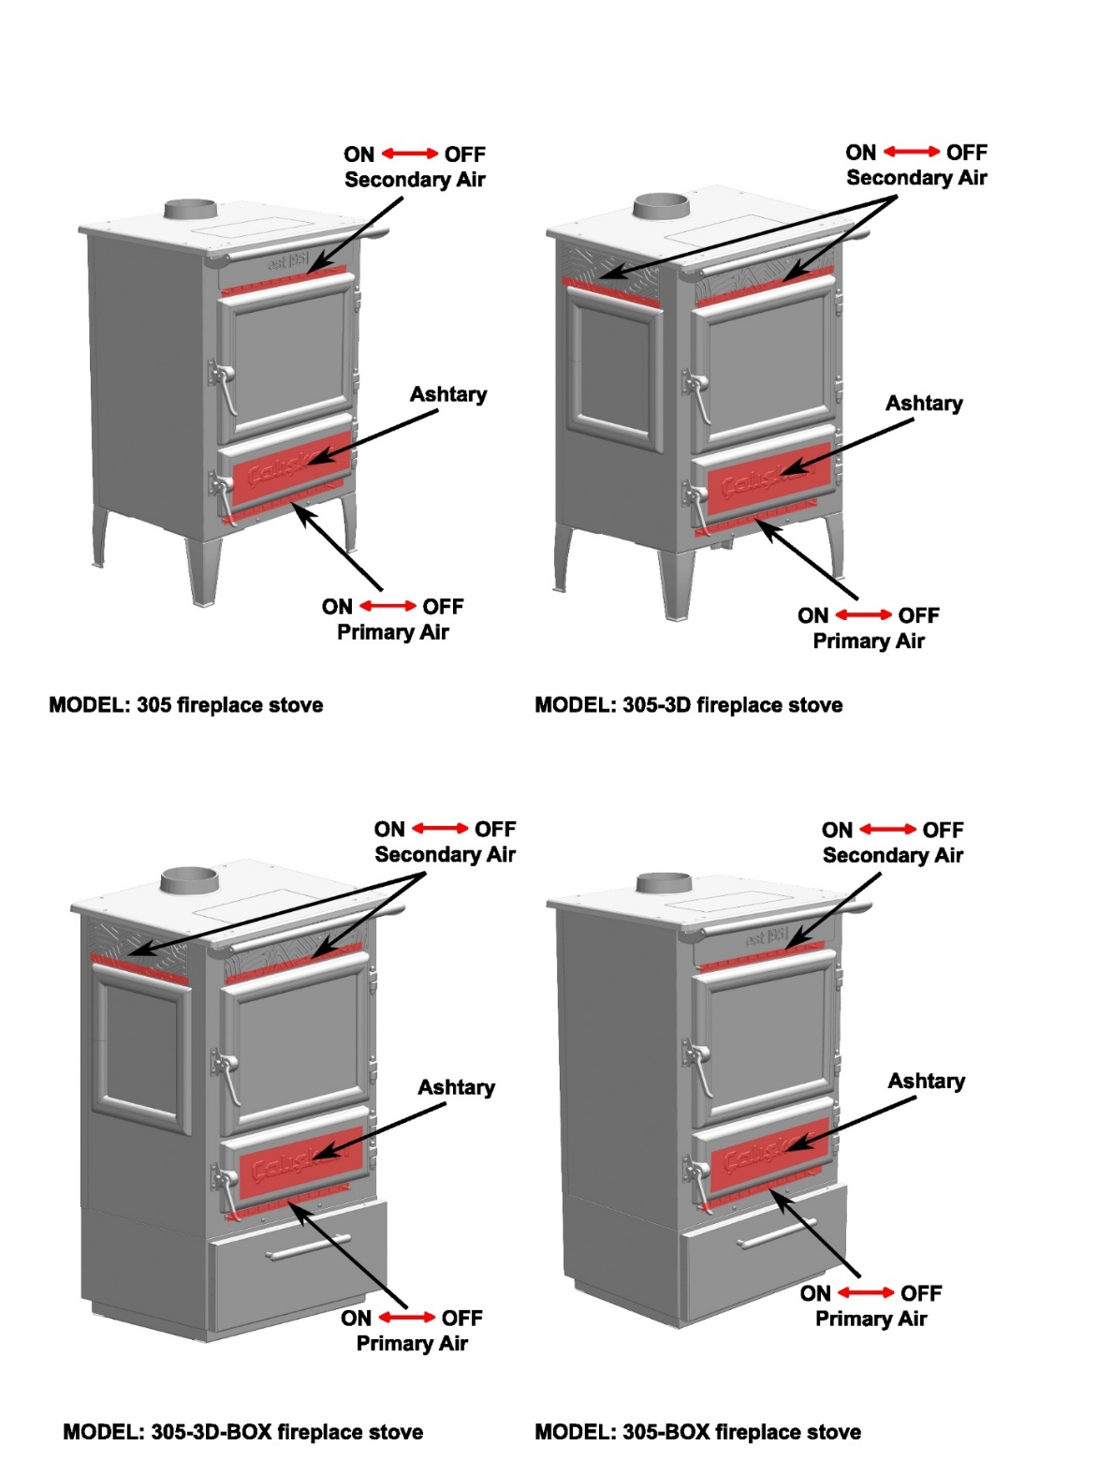

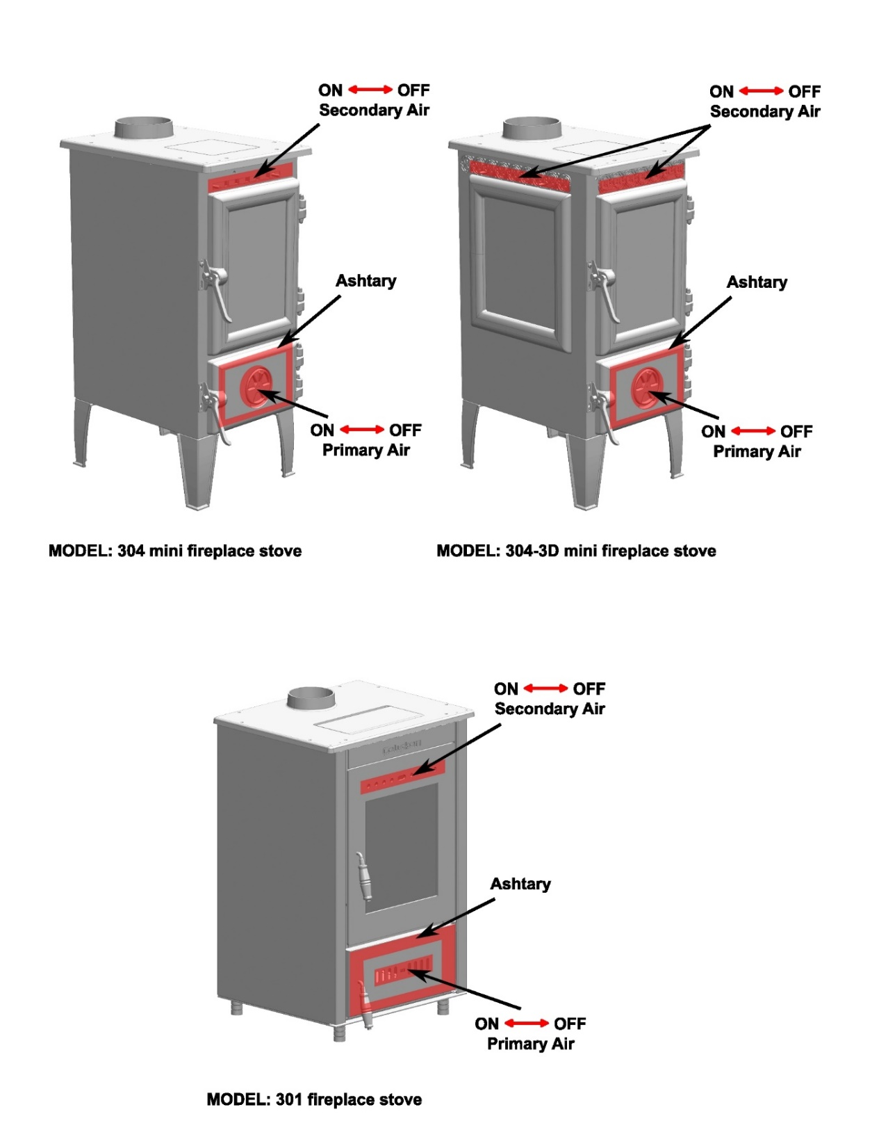
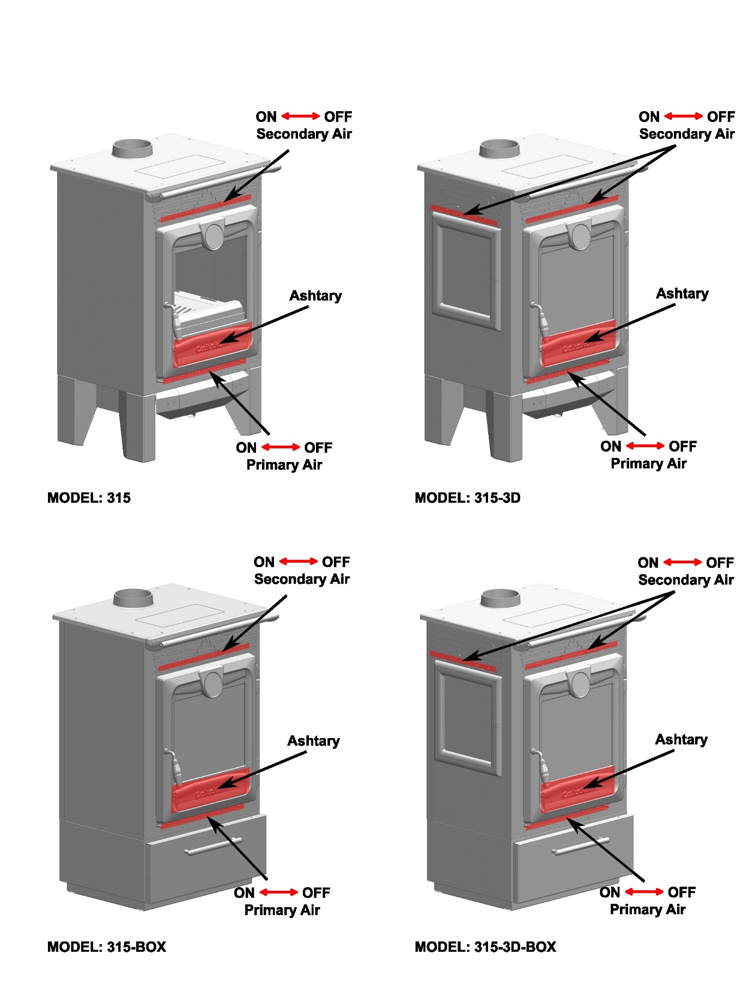

IMPORTANT!
For safety reasons the door of the hearth can be opened only for the loading of the fuel. The hearth door must always remain closed during operation or rest.
Never overload the stove. Too much fuel and too much air for the combustion may cause overheating and then damage the stove. You should always use the stove with the door closed in order to avoid damages due to overheating (forge effect). The inobservance of this rule makes the warranty expire.
The stove works as an intermittent operating appliance. Besides the adjustment of the air for the combustion, the intensity of the combustion and consequently the thermal performance of the stove is influenced by the stack. To verify the good combustion, check whether the smoke coming out from the stack is transparent. If it is white, it means that the stove is not properly adjusted or the wood is too wet; if instead the smoke is gray or black, it signals that the combustion is not complete.
WARNING!
When fuel is added onto the embers in the absence of a flame, a considerable amount of fumes may develop. Should this happen, an explosive mixture of gas and air may form, and in extreme cases an explosion may occur. For safety reasons it is advisable to perform a new lighting procedure with the use of small strips.
WARNING!
Do not place heavy materials on the stove when it is hot or cold. Such materials may deform the upper part of the stove over time, causing it to collapse!

OPERATION IN TRANSITION PERIODS
During transition periods when the external temperatures are higher, if there is a sudden increase of temperature it can happen that the combustion gases inside the flue cannot be completely sucked up.
The exhaust gases do not come out completely (intense smell of gas). In this case, shake the grating more frequently and increase the air for the combustion. Then, load a reduced quantity of fuel in order to permit a rapid burning (growing up of the flames) and the stabilization of the draught. Then, check that all openings for the cleaning and the connections to the stack are air-tight. In case of doubt, DO NOT operate the product.

3.4. ASH CLEARANCE AND DEFLECTORS
Before removing ash ensure that it has cooled down. The ashpan slides out for easy ash removal.
To make ash removal easier there are ash carriers available. You can buy these from a supplier.
WARNING!
The lack of the deflectors causes a strong depression, with a too fast combustion, an excessive consumption of wood with related overheating of the stove.

4. MAINTENANCE AND IMPORTANT ADVICES
Check the external air intake, by cleaning it, at least once a year. The stack must be regularly swept by the chimney sweeper. Let your chimney sweeper in charge of your area check the regular installation of the device, the connection to the stack and the aeration.
IMPORTANT!
THE MAINTENANCE MUST BE CARRIED OUT ONLY AND EXCLUSIVELY WITH COLD STOVE.
You should only use spare parts approved and supplied by Çalışkan Please contact your specialized seller if you require spare parts.
YOU MUST NOT MAKE ANY CHANGES TO THE STOVE!!!

4.1. FIREBOX, COOKING OVEN AND FLUEWAY CLEANING
GLASS CLEANING
Thanks to a specific inlet of secondary air, the accumulation of dirty sediments on the glass-door is reduced with efcacy. Nevertheless this can never be avoided by using solid fuels (particularly wet wood ) and it has not to be understood as a defect of the stove.
IMPORTANT!
The cleaning of the sight glass must be carried out only and exclusively with cold stove to avoid the explosion of the same. For the cleaning, it is possible to use specific products or a wet newspaper paper ball passed in the ash to rub it. Do not use cloths, abrasive or chemically aggressive products by cleaning the hearth glass.
The correct lighting phase, the use of proper quantities and types of fuels, the correct position of the secondary air regulator, enough draught of the chimney-flue and the presence of combustion air are the essential elements for the optimal functioning of the stove and for the cleaning of the glass.

BREAK OF GLASSES!
Given that the glass-ceramic glasses resist up to a heat shock of 750°C, they are not subject to thermal shocks. Their break can be caused only by mechanic shocks (bumps or violent closure of the door, etc.). Therefore, their replacement is not included in the warranty.

CLEANING OUT THE ASHES
All the stoves are equipped with a hearth grating and an ash drawer for the collection of the ashes Picture 9. It is suggested to empty periodically the ash drawer and to avoid it filled completely in order not to overheat the grating. Moreover, it is suggested to leave always 3-4 cm of ash in the hearth.
WARNING!
The ashes removed from the hearth have to be stored in a container made of fire-resistant material equipped with an air-tight cover. The container has to be placed on a fire-resistant floor, far from flammable materials up to the switching off and complete cooling.

ENAMEL CLEANING
For the cleaning of enamelled surfaces use soap water or not aggressive and not chemically abrasive detergents.
IMPORTANT!
After the cleaning do not let soapy water or any cleanser dry but remove them immediately. DO NOT use sandpaper or steel wool.

4.2. CHIMNEY SWEEPING
The correct lighting phase, the use of proper quantities and types of fuels, the correct position of the secondary air regulator, enough draught of the chimney-flue and the presence of combustion air are the essential elements for the optimal functioning of the stove. The stove should be completely cleaned at least once a year or every time it is needed (in case of bad working and low yield). An excessive deposit of soot can cause problems in the discharge of smokes and fire in the flue.
The cleaning must be carried out exclusively with cold equipment. This operation should be carried out by a chimney sweeper who can simultaneously perform an audit of the flue (checking of possible deposits)!
During the cleaning, it is necessary to remove the ash drawer, the grating, and the smoke deflectors from the stove in order to ease the fall of the soot. The deflectors can be easily extracted from their seats since they are not fastened using screws. Once the clearing has been carried out, place them back in their seats (Picture 7).

4.3. IMPORTANT ADVICES
WARNING!
Çalışkan declines any responsibility for the product that has been modified without written authorization as well as for the use of non-original spare parts.
It is obligatory to respect the National and European rules, local regulations concerning building matter and also fireproof rules.
NO MODIFICATIONS CAN BE CARRIED OUT TO THE APPLIANCE. Çalışkan cannot be held responsible for lack of respect for such precautions.

SUMMER STOP
After cleaning the hearth, chimney and hood, totally eliminating the ash and other eventual residues, close all the doors of the hearth and the relevant registers; in case you disconnect the stove from the chimney you must close its openings in order to let work others possible stoves connected to the same flue.
We suggest performing the cleaning operation of the flue at least once per year; verifying in the meantime the actual status of the rope seals, which cannot ensure the good operation of the equipment if they are not in good condition and are not making a good seal! In this case the seals must be replaced.
In presence of dampness in the room where the stove has been placed, we advise you to put absorbent salts into the hearth.
If you want to keep for long the aesthetic look of the cooker it is important to protect its internal walls in row cast iron with neutral Vaseline!
ADDITIONAL WARNINGS
• Only use the fuel recommended by the manufacturer. The product must not be used as an incinerator.
• Do not use the product as a ladder or supporting structure.
• Do not place laundry on the product to dry it. Any clothes-horse or similar objects must be kept at due distance from the product. Danger of fire or damage to the coating.
• The user is fully liable for any incorrect use of the product. The manufacturer bears no civil or criminal liability for incorrect use.
• Unauthorised tampering of any nature or replacement of spare parts of the product with non-original parts may endanger the operator and the manufacturer bears no civil or criminal liability for this.
• Large parts of the surface of the product can get very hot (door, handle, glass, smoke outlet pipes, etc.). Please therefore avoid coming into contact with these parts without wearing suitable protective clothing or using appropriate measures, such as heat protective gloves.
• DO NOT use the product with the door open or if the glass is broken.
• Turn off the product in the event of a failure or malfunctioning.
• Do not wash the product with water.
• Installations not complying with the regulations in force, as well as incorrect use and failure to comply with the maintenance scheduled by the manufacturer, will invalidate the guarantee.
IN AN EMERGENCY
If there is a free in the flue connection:
a) Close the loading door and the ash drawer door
b) Close the comburent air registers
c) Use carbon dioxide ( CO2 powder ) extinguishers to put out the free
d) Request the immediate intervention of the Fire Brigade
DO NOT EXTINGUISH THE FIRE WITH WATER!
When the flue stops burning, have it checked by a specialist to identify any cracks or permeable points.

4.4. TROUBLE SHOOTING
If the fire does not burn, check the following:
• the air inlet is not obstructed in any way,
• chimneys and flueways are clear,
• a suitable fuel is being used,
• there is an adequate air supply into the room,
• there is sufficient draw in the chimney.

In case the door glass blackening, the following points can be taken into consideration;
• Wet or unseasoned wood, or logs will cause the glass to blacken.
• The airwash relies on a supply of heated air to keep the glass clean, therefore, when lighting the stove allow the firebed to become well established before closing the air control. This may also be necessary when re-fuelling the stove.
• Do not completely close the air control. It is always more difficult to keep the glass clean when running the stove very slowly for long periods.
If blackening of the glass still occurs check that all flue connections and the blanking plate are well sealed.

STORAGE OF THE STOVE
If the stove must be kept turned off for a long time, store it in a dry, clean and closed place.

4.5. IF YOU NEED FURTHER HELP
If you need further help with your Çalışkan then your Installer will be able to provide the answers to most questions. Your Çalışkan seller has a great deal of experience and will also be able to provide helpful advice.



Hüsnü Örnek Sk. No:12,
Organize Sanayi Bölgesi 20330
Honaz Denizli/Türkiye
info@caliskanisi.com.tr,
phone:+90 258 269 10 23

